Unlocking the Power of Predictive Analytics: Transform Data into Smarter Decisions Today!

In today’s data-driven world, harnessing the full potential of predictive analytics is no longer just an advantage, it's a necessity. Imagine being capable of forecast trends, predict customer needs, and make informed decisions that drive your business ahead. Predictive analytics transforms vast amounts of data into actionable insights, enabling organizations to uncover hidden patterns and trends. This powerful tool enhances strategic planning. It also boosts operational efficiency. These improvements give businesses the edge they need to stay ahead in a competitive landscape. Whether you are in marketing, finance, or any sector reliant on data, you can revolutionize your decision-making process. Understand how to leverage predictive analytics effectively. Ready to unlock the power of predictive analytics and turn your data into smarter decisions today? Dive in and discover how to propel your business towards success with this game-changing technology!

- The Role of DevOps in Faster, Smarter Product Delivery
Welcome back to the blog! If you’ve ever wondered how great teams launch new software features seemingly overnight without breaking a sweat, you’re in the right place. This week, we’re diving into the world of DevOps—a dynamic approach that’s been reshaping how products are built, tested, and delivered at lightning speed. Whether you’re a developer, product manager, or just someone curious about the magic behind smooth launches, there’s something here for you.
Now, DevOps might sound like a buzzword or just another IT fad, but it’s much more than that. At its core, DevOps is about breaking silos between developers and operations teams to foster collaboration, automation, and continuous improvement. It’s like turning a tricky relay race into a well-choreographed dance where everyone knows their moves and timing perfectly.
So how does such an approach translate into faster, smarter product delivery? Let’s unpack some key ways DevOps supercharges the development lifecycle:
- Continuous Integration and Continuous Delivery (CI/CD): By automatically integrating code changes and deploying them through automated pipelines, teams can push updates several times a day rather than waiting weeks or months. This means buggy features are caught early, and valuable enhancements reach users faster.
- Automated Testing: Manual testing is a thing of the past. Automated tests run quickly and consistently every time new code hits the repository, giving teams instant feedback. This dramatically reduces the risk of breaking something down the line, keeping quality sharp without slowing down innovation.
- Infrastructure as Code (IaC): Managing servers and environments used to be manual and error-prone. Now, coding your infrastructure setups ensures environments are reproducible and scalable. Need a test environment up? Spin it up with a few commands. This adds flexibility and speed that's hard to beat.
- Collaboration and Transparency: DevOps encourages cross-team communication through shared tools and dashboards. Everyone from developers to ops engineers can see what’s happening in real time, making it easier to spot bottlenecks or issues before they snowball.
But beyond the technical perks, DevOps fosters a culture that values experimentation and learning. When mistakes don’t mean blame but an opportunity to improve, teams feel safer taking calculated risks—leading to more creative solutions and better products.
If you’re starting to think, “This all sounds great, but how do I get started?” Consider small steps like introducing automated testing into your current workflow or setting up a simple CI/CD pipeline for a pet project. Over time, these shifts build momentum and transform the whole development process.
Thanks for joining me for this deep dive into the power of DevOps. Next week, we’ll explore some real-world success stories where companies turbocharged their delivery pipelines and the lessons learned along the way. Until then, keep experimenting, and remember: the best products are built with both speed and thoughtfulness.
Stay curious and connected!

- Local SEO Strategies to Boost Small Business Growth
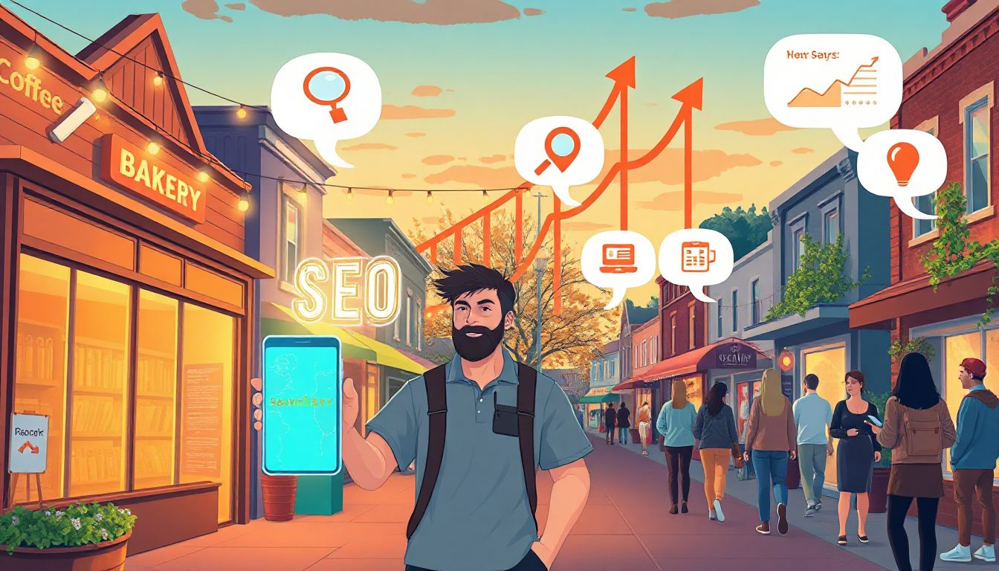
Imagine a customer types "best pizza near me" into their phone while walking down your street. Your shop pops up first, and they step inside. Or, a rival takes that spot, and you miss the sale. Local SEO turns those quick searches into real visits for small businesses like yours.
This matters because people grab their phones for nearby spots more than ever. About 46% of all Google searches seek local info, and most happen on mobile. You can beat big chains by showing up right when folks need you. Local SEO helps your business shine in spots like Google Maps and the top three results, called the local pack.
We'll cover steps from setting up your Google spot to handling reviews. These tips fit cafes, shops, or services in your town. Get ready to grow your crowd and keep customers coming back.

Understanding the Foundations of Local SEO
Local SEO starts with the basics. It helps small businesses show up when people hunt for services close by. Skip this, and you blend into the noise.

What is Local SEO and Why It Matters for Small Businesses
Local SEO means tweaking your online spots to match searches tied to places. Think of it as a signpost pointing customers straight to your door. For small shops, it evens the odds against huge stores that spend big on ads.
Why care? Nearby buyers make up 28% of all searches, and they often visit within a day. Check your current setup with free tools like Google Search Console. It shows if folks find you or not. Start an audit today—list where you appear online and spot weak points. This simple check can reveal hidden chances to pull in more locals.

Key Differences Between Local and General SEO
Local SEO zeros in on where you are and what you offer there. General SEO aims wider, like for anyone in the country. In local, distance counts a lot—Google picks spots based on how close you sit to the searcher.
Focus on your name, address, and phone number, known as NAP. Keep it the same on every site, from your page to Yelp. Mismatches confuse search engines and drop your rank. Target questions like "top barber in downtown Seattle." These pull in ready buyers, unlike broad terms that waste time.

Measuring Local SEO Success
Track your wins with clear numbers. Look at where you rank for local terms, visits from those searches, and how many turn into sales. Tools like Google Analytics let you see calls or map clicks from your area.
Set goals, such as 20% more directions requests each month. Watch traffic from "near me" queries. If a coffee shop sees jumps in foot traffic after tweaks, that's proof it works. Tie these to revenue—say, each new visitor buys $10 worth. Review monthly to adjust and keep growing.

Optimizing Your Google Business Profile for Maximum Visibility
Google rules local searches. Your Business Profile acts as your front window. Nail this, and more eyes land on you.

Claiming and Verifying Your Profile
First, hunt for your business on Google. If it shows, claim it fast. No profile? Make one at business.google.com. Add your details, then verify with a postcard or call—they send a code to prove it's yours.
Verification builds trust. Without it, you can't edit or reply to reviews. Upload clear photos of your shop, team, and goods. Set exact hours, even for holidays. A bakery that lists fresh bread pics and open times from 7 a.m. draws more morning crowds. This setup lifts you in the local pack, where 84% of searchers click.

Enhancing Profile Details for Relevance
Fill every box. Pick categories that fit, like "Italian restaurant" not just "food." Add traits such as "wheelchair accessible" or "free Wi-Fi." These match what users type.
Write a short bio with local flavor—mention your spot in the historic district. List services, like delivery zones. Post updates on deals, say "Buy one latte, get one half off this week." A retail store that does this sees higher clicks because Google favors active profiles. Keep it real to hook passersby.

Managing Photos, Posts, and Updates
Photos pull people in. Aim for 10 or more: inside shots, products, and happy faces. Fresh ones beat stock images every time. Google's algorithm likes visuals that show a lively place.
Post weekly. Share events, new items, or tips. "Join our trivia night Friday!" keeps you top of mind. Profiles with regular posts get 2.5 times more views. For a gym, updating class schedules boosts sign-ups. Manage this often to stay ahead—it's like tending a garden for steady blooms.

Building and Managing Local Citations for Authority
Citations are like nods from the online neighborhood. They tell search engines you're legit. Build them right, and your rank climbs.

What Are Local Citations and Their Impact
Citations list your NAP on other sites. No link needed—just your info out there. They prove you're real and help Google trust you more.
Strong citations lift rankings. Start with big ones: Yelp, Apple Maps, Bing. A plumber adds to 50 sites and sees calls double. They act as votes for your spot in town.

Strategies for Consistent Citation Building
Audit what exists. Use sites like BrightLocal to find and fix old ones. Submit to local directories, like chamber of commerce pages.
Pick ones for your field—auto shops hit Angie’s List. Tools like Moz Local handle batches. Keep NAP exact; one wrong zip code hurts. A small diner submits to 20 spots and watches map views rise 30%. Build slow but sure for lasting power.

Monitoring and Fixing Citation Errors
Check monthly. Set Google Alerts for your name. Spot duplicates? Merge them on the site.
Update fast if you move or change numbers. Tools scan for errors automatically. Fix a bad address, and traffic flows better. This upkeep strengthens your base, like patching a roof before rain.

Leveraging On-Page and Technical SEO for Local Searches
Your website ties it all together. Make it local-friendly, and searches lead home.

Incorporating Local Keywords Effectively
Find words like "florist in Austin" with Google Keyword Planner. Weave them into titles: "Top Florist in Austin for Weddings." Use in content, but keep it natural.
Aim for easy wins—terms with few rivals but good searches. A boutique adds "vintage clothes in Brooklyn" to pages and ranks higher. This draws folks who mean business.

Creating Location-Specific Landing Pages
Build pages for each town you serve. "Our Services in Miami" with a map and local tips. Add testimonials from area folks.
Use schema code for better display—stars and addresses in results. A repair shop makes one per neighborhood and gets more leads. These pages feel personal, like a chat with a neighbor.

Ensuring Mobile-Friendliness and Site Speed
Most local hunts happen on phones. Test yours at search.google.com/test/mobile-friendly.
Speed up with smaller images and clean code. Slow sites lose 53% of visitors. A fast cafe page keeps users scrolling for menus. Good mobile setup means higher spots for "near me" finds.

Harnessing Customer Reviews and Local Engagement
Reviews sway choices. They’re your word-of-mouth online. Engage, and trust grows.

Encouraging and Responding to Reviews
Ask nicely after a sale: "Loved your visit? Share on Google!" Use emails or cards.
Reply to every one. Thank positives; fix negatives with care. "Sorry about the wait—we're adding staff." This shows you listen, and Google rewards it with better ranks. A salon responds quick and sees review scores climb.

Integrating Reviews into Your Website
Embed Google reviews on your home page. Pull in fresh ones with widgets.
Feature stories: "Jane from down the block raves about our pies." Keep it honest—no fakes, or you risk bans. This builds warmth, like friends vouching for you.

Participating in Local Online Communities
Join Facebook groups for your town. Share tips, like "Rainy day recipe ideas."
Answer questions without pushing sales. "Try our spot for tools." This sparks links and mentions. A bookstore chats in local forums and gains loyal readers. It's real talk that pays off.

Conclusion: Implementing Local SEO for Lasting Small Business Success
Local SEO packs real punch for small outfits. Claim that Google profile, keep citations clean, tweak your site for locals, and chat with reviewers. These moves spike visits and sales.
Start small—verify today and post once a week. Watch numbers grow, like more calls or packed tables. Stick with it, and you'll own your corner of searches.
Adapt as things change. Check tools often. Your business deserves that edge—go claim it now and watch customers roll in.

LinkedIn Ads vs Facebook Ads: Which Works Better for B2B?

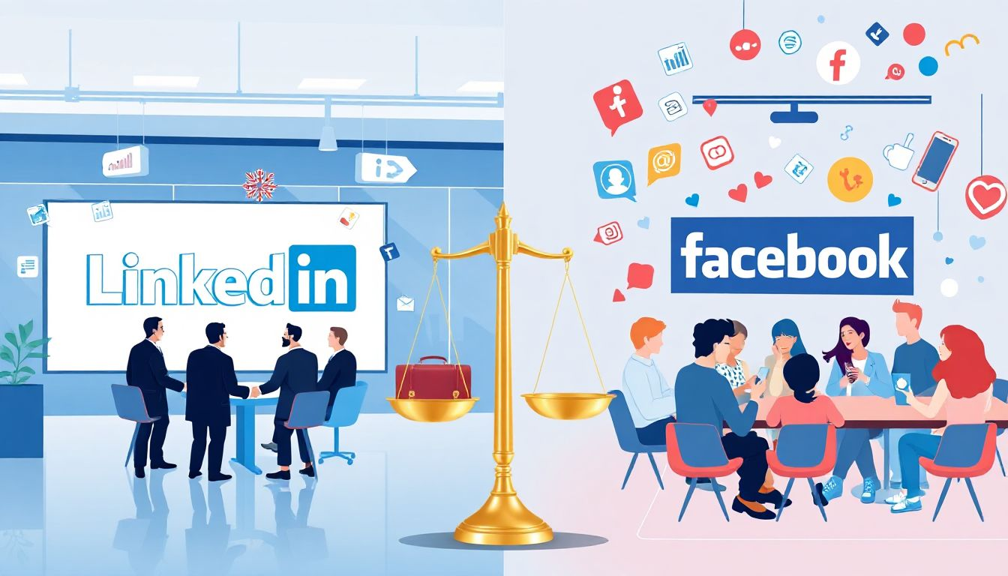

When it comes to finding the perfect platform for B2B marketing, the debate between LinkedIn Ads vs Facebook Ads: Which Works Better for B2B? has kept marketers up at night for years. Let’s dive into a friendly conversation about what makes each platform tick and how real-life experiences and insights from fellow marketers can help us decide. Imagine sitting down with a friend over coffee, sharing anecdotes from key discussions on forums and social posts where peers have spilled their honest opinions. That’s the vibe we’re aiming for here’s a mix of personal story, practical observations, and a bit of “aha!” moments that make the challenges and triumphs of digital advertising feel all too real. In a world where every dollar counts, the journey to choose the perfect platform is more than just numbers; it’s about genuine connection, smart targeting, and meaningful conversations with your audience.

The Platform Strengths: Connecting with a Professional Audience
Picture this: you’re trying to reach decision-makers at companies, and you know that every impression counts. LinkedIn, with its reputation as the professional social network, naturally attracts a crowd that comes to work thinking seriously about business goals. Many marketers share stories like the ones you’d find in animated Reddit threads or passionate Quora discussions of LinkedIn’s powerful audience segmentation. Its robust targeting based on industry, job title, and company size creates a direct line to those who make the calls. In conversations, it’s often mentioned that while Facebook’s vast reach might appear tempting, LinkedIn’s quality of engagement is unmatched when your goal is to speak directly to business leaders.

It’s interesting to note that several users in community discussions reveal that creating content for LinkedIn feels almost like tailoring a bespoke suit: it requires an understanding of not just demographics but the professional mindset. With straightforward tools and a myriad of options to refine campaigns, LinkedIn often outshines Facebook by giving B2B advertisers the opportunity to nuance their messaging. Can you imagine trying to capture the attention of a CFO or a senior manager from just a quick scroll on Facebook? The shared experiences and collective wisdom found in lively online exchanges underscore a central belief: when quality and precision matter, professionalism matters most. The narrative is familiar in many digital marketing circles, a platform that hones in on business objectives and career accomplishments naturally wins the hearts of customers looking for a more enriched and targeted engagement.

Moreover, the conversational tone and anecdotal spirit found across social platforms teach us that LinkedIn’s interface encourages networking and direct business interactions. It’s less about casual likes and more about meaningful discussions, making it a natural playground for companies that invest in long-term relationships. The stories circulating online echo a simple truth: if your aim is to penetrate the boardrooms and decision-making circles, LinkedIn offers an environment where your message can resonate deeply. Whether you're a small startup or an established enterprise, the platform’s alignment with professional branding creates an inherent advantage that many advertisers find invaluable.

Firsthand Experiences: Stories from the Digital Battlefield
Nothing speaks louder than personal tales from the frontline of digital advertising. Many marketers find themselves sharing relatable experiences in communities, where one post can spark a thousand conversations. I’ve come across multiple narratives that emphasize the importance of trial, error, and learning directly from the digital battlefield. One marketer likened launching a LinkedIn campaign to maneuvering through an exclusive networking event where each interaction is carefully curated to build lasting relationships. This sentiment resonates with several Quora discussions and even a few spirited Twitter threads that have emerged over time.

The key insight here is that every campaign tells a story. While Facebook Ads can be seen as a bustling marketplace with an array of voices and endless chatter, LinkedIn offers an environment dedicated to substantive exchange. Imagine navigating a crowded bazaar versus engaging in a quiet boardroom discussion; both have merits, but for businesses looking to engage at a deeper level, the boardroom conversation often holds more promise. Personal anecdotes from successful campaigns reveal that the qualitative differences between the platforms can significantly affect outcomes. For instance, some have noted that even when budgets were tight, the precision of LinkedIn’s targeting meant that every interaction held potential, turning occasional clicks into meaningful business leads.

Beyond the numbers and metrics, what really separates the platforms is the human element. Engaging with the right audience doesn’t always mean chasing viral trends; it might involve a consistent, thoughtful outreach strategy that fosters genuine relationships. These firsthand experiences, shared organically across digital communities, reinforce the idea that while both platforms have their charm, the choice boils down to your specific audience and campaign goals. The recurring advice among these seasoned voices is clear: experiment, measure, and trust the process. In doing so, you’ll uncover which platform truly aligns with your business vision and objectives, a lesson that remains at the heart of every successful B2B campaign.

Wrapping It Up: Choosing Your Digital Champion
In closing, the journey to determine which platform LinkedIn Ads or Facebook Ads reigns supreme in the B2B landscape is as personal as it is data-driven. Over lively discussions and shared experiences on Reddit, Quora, and Twitter, one consistent theme emerges: understand your audience and the unique vibe each platform offers. While Facebook Ads provide a wide-reaching dispersal of your message, LinkedIn’s focused, professional environment often proves more effective for campaigns aiming at business decision-makers.

The conversational insights and firsthand accounts underscore a compelling reality: success in B2B advertising isn’t about choosing a one-size-fits-all approach. It’s about balancing budgetary considerations with the quality of engagement. If you’re striving to secure meaningful connections and drive serious business results, it might be time to lean into the platform that intimately understands professional networks. Consider this a call to action experiment with both approaches, monitor performance keenly, and engage actively with your community for feedback. In the end, your ideal strategy may well be a hybrid model, blending the strengths of each platform to maximize reach and relevance.

Embrace the journey as you refine your digital tactics. The insights drawn from seasoned marketers and extensive discussions remind us that the right choice hinges on knowing your audience, investing in quality interactions, and being adaptable in a rapidly changing digital world. Happy campaigning, and may your digital endeavors open doors to many fruitful B2B engagements!

